Java Package
A java package is a group of similar types of classes, interfaces and sub-packages.
Package in java can be categorized in two form, built-in package and user-defined package.
There are many built-in packages such as java, lang, awt, javax, swing, net, io, util, sql etc.
Advantage of Java Package
1) Java package is used to categorize the classes and interfaces so that they can be easily maintained.
2) Java package provides access protection.
3) Java package removes naming collision.
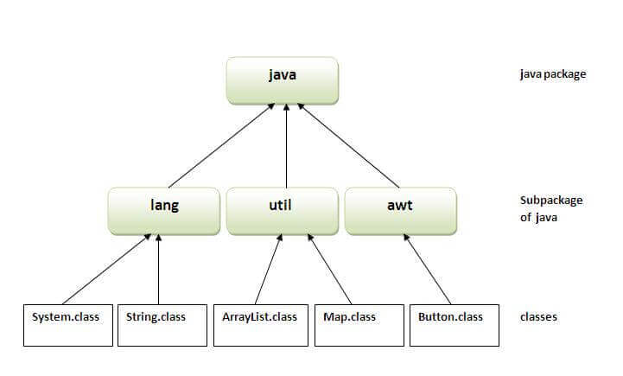
1. Using packagename.*
1. If you use package.* then all the classes and interfaces of this package will be accessible but not subpackages.
The import keyword is used to make the classes and interface of another package accessible to the current package.
Example of package that import the packagename.*
//save by A.java
package pack;
public class A{
public void msg(){System.out.println("Hello");}
}

//save by B.java
import pack.*;
class B{
public static void main(String args[]){
A obj = new A();
obj.msg();
}
} // public Access Modifier
Output:Hello
2) Using packagename.classname
If you import package.classname then only declared class of this package will be accessible.
Example of package by import package.classname
//save by A.java

package pack;
public class A{
public void msg(){System.out.println("Hello");}
}
Public class x{
Public void xyz(){System.out.println(“XYZ Class initiated”);}
}

//save by B.java
import pack.A;
class B{
public static void main(String args[]){
A obj = new A();
obj.msg();
}
}
Output:Hello
3) Using fully qualified name
If you use fully qualified name then only declared class of this package will be accessible. Now there is no need to import. But you need to use fully qualified name every time when you are accessing the class or interface.
It is generally used when two packages have same class name e.g. java.util and java.sql packages contain Date class.
Example of package by import fully qualified name
package pack;
public class A{
public void msg(){System.out.println("Hello");}
}
//save by B.java
class B{
public static void main(String args[]){
pack.A obj = new pack.A();//using fully qualified name
obj.msg();
}
}
Output:Hello

